BANK LOAN REPORT QUERY DOCUMENT
- BANK LOAN REPORT | SUMMARY
KPI’s:
Total Loan Application:
select count(*) as Total_Application from banking_loan
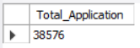
MTD Loan Applications
select count(id) as MTD_Application from Banking_loan
where MONTH(issue_date) = 12 and year(issue_date) = 2021
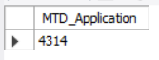
PMTD Loan Applications
select count(id) as PMTD_Application from banking_loan
where Month(issue_date) = 11
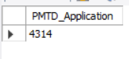

Total Funded Amount
select sum(loan_amount) as Total_Funded_Amount from banking_loan
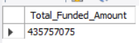
MTD Total Funded Amount
select sum(loan_amount) as MTD_Funded_Amount from banking_loan
where month(issue_date) = 12
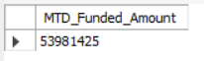
PMTD Total Funded Amount
select sum(loan_amount) as PMTD_Funded_Amount from banking_loan
where month(issue_date) = 11


Total Amount Received
select sum(total_payment) as Total_Amount_Received from banking_loan
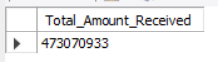
MTD Total Amount Received
select sum(total_payment) as MTD_Amouunt_Recived from banking_loan
where month(issue_date) = 12 and year(issue_date) = 2021
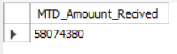

PMTD Total Amount Received
select sum(total_payment) as PMTD_Amouunt_Recived from banking_loan
where month(issue_date) = 11
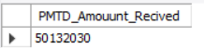

Average Interest Rate
select avg(int_rate) * 100 as Average_Interest_Rate from banking_loan
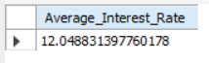
MTD Average Interest Rate
SELECT AVG(int_rate) *100 as MTD_Average_Interest_Rate FROM BANKING_LOAN
WHERE MONTH(issue_date)=12
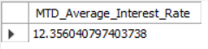

PMTD Average Interest Rate
SELECT AVG(int_rate) *100 as PMTD_Average_Interest_Rate FROM BANKING_LOAN
WHERE MONTH(issue_date)=11
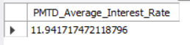

Avg DTI
select avg(dti) * 100 as Avg_DTI from banking_loan
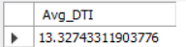

MTD Avg DTI
select avg(dti) * 100 as MTD_Avg_DTI FROM BANKING_LOAN
WHERE MONTH(issue_date)=12
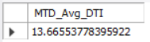

PMTD Avg DTI
select avg(dti) * 100 as PMTD_Avg_DTI FROM BANKING_LOAN
WHERE MONTH(issue_date)=11
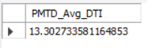

GOOD LOAN ISSUED
Good Loan Percentage
SELECT (COUNT(CASE WHEN loan_status = 'Fully Paid' OR loan_status = 'Current' THEN id END) * 100.0) /
COUNT(id) AS Good_Loan_Percentage
FROM banking_loan
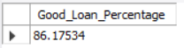
Good Loan Applications
select count(id) as Good_Loan_Application from banking_loan
where loan_status='Fully Paid' or loan_status='Current'
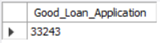

Good Loan Funded Amount
select sum(loan_amount) as Good_loan_funded_amount from banking_loan
where loan_status='Fully Paid' or Loan_status='Current'
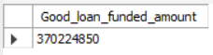

Good Loan Amount Received
select sum(total_payment) as Good_loan_amount_received from banking_loan
where loan_status='Fully Paid' or Loan_status='Current'
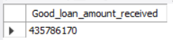

BAD LOAN ISSUED
Bad Loan Percentage
select (count(case when loan_status='Charged Off' then id end) * 100) / count(id) as Bad_Loan_Percentage from banking_loan
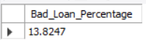

# Bad Loan Applications
select count(id) as Bad_Loan_Application from banking_loan
where loan_status = 'Charged Off'
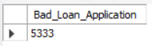

# Bad Loan Funded Amount
select sum(loan_amount) as Bad_Loan_Funded_Amount from banking_loan
where loan_status='Charged Off'
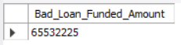
# Bad Loan Amount Received
select sum(total_payment) as Bad_Loan_Amount_Recived from banking_loan
where loan_status='Charged Off'
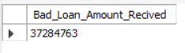

Loan Status
select loan_status,
count(id) Loan_Count,
sum(loan_amount) Total_Funded_Amount,
sum(total_payment) Total_Recived_Amount,
avg(int_rate * 100) Interest_Amount,
avg(dti * 100) DTI
from banking_loan
group by loan_status
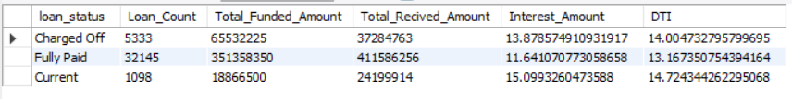
- BANK LOAN REPORT | OVERVIEW
MONTH
select month(issue_date) as month_number,
monthname(issue_date) as Month_Name,
sum(loan_amount) as Total_Funded_Amount,
sum(total_payment) as Total_Payment_Recived
from banking_loan
GROUP BY month_number, Month_Name
ORDER BY month_number
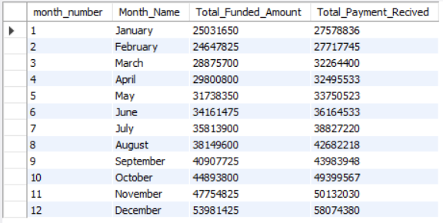

STATE
select address_state as State,
count(id) as Total_Application_Loan,
sum(loan_amount) as Total_Funded_Amount,
sum(total_payment) as Total_Recived_Amount
from banking_loan
group by State
order by state
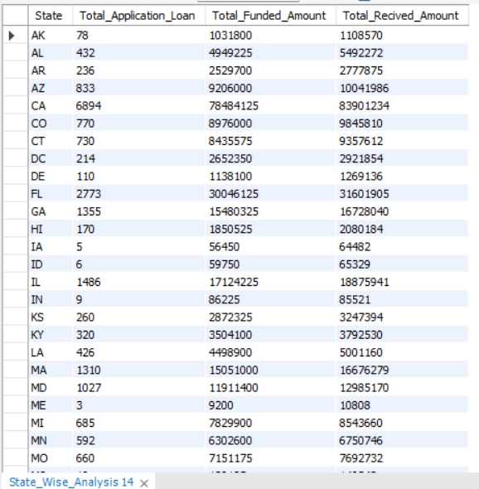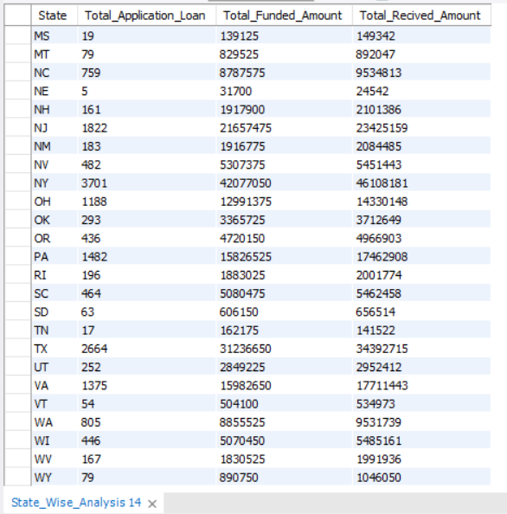

TERM
select term as Term,
count(id) as Total_Loan_Application,
sum(loan_amount) as Total_Funded_Amount,
sum(total_payment) as Total_Recived_Payment
from banking_loan
group by Term
order by term
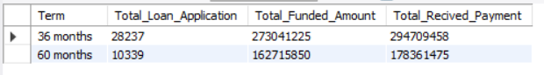
EMPLOYEE LOAN DURATION
select emp_length as Employee_Duration,
count(id) as Total_Loan_Application,
sum(loan_amount) as Total_Loan_Amount,
sum(total_payment) as Total_Recived_Amount
from banking_loan
group by emp_length
order by emp_length
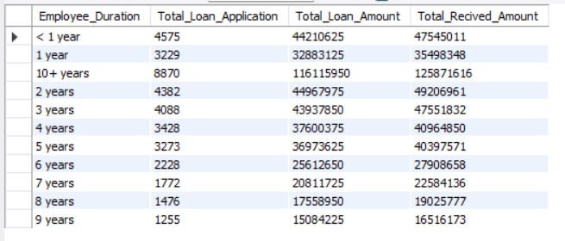
PURPOSE
select purpose as Purpose,
count(id) as Total_Loan_Application,
sum(loan_amount) as Total_Loan_Amount,
sum(total_payment) as Total_Recived_Amount
from banking_loan
group by Purpose
order by purpose
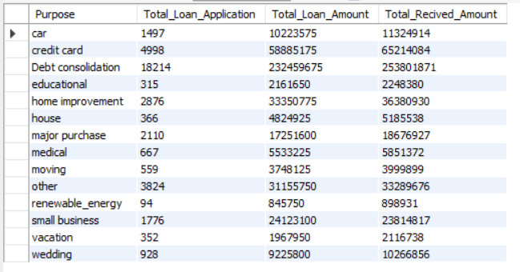

HOME OWNERSHIP
select home_ownership as Home_Ownership,
count(id) as Total_Loan_Application,
sum(loan_amount) as Total_Loan_Amount,
sum(total_payment) as Total_Recived_Amount
from banking_loan
group by Home_Ownership
order by Home_Ownership
